#IronCard Cashback Program

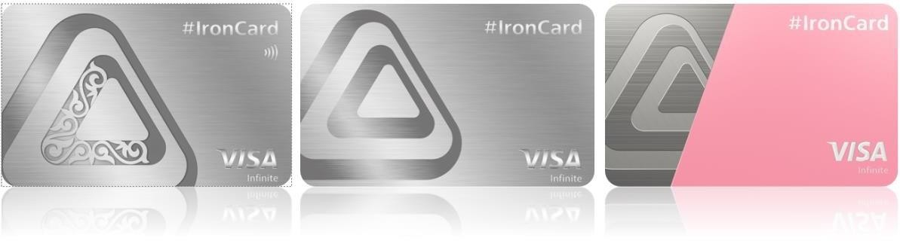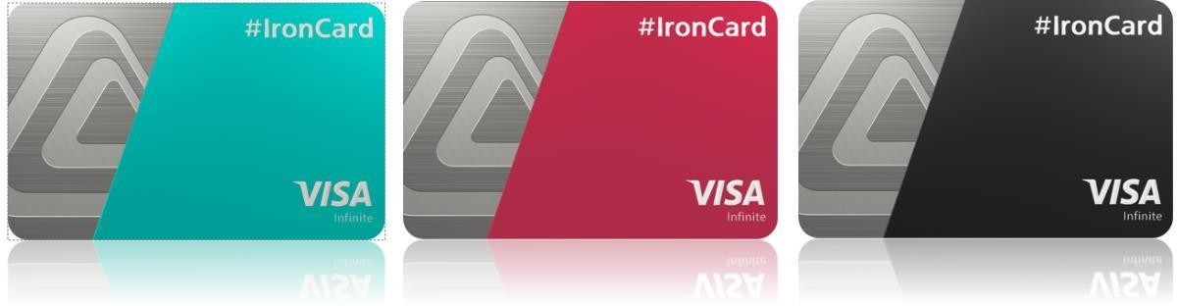

Cashback Program
1.1. The Program is designed to increase customer loyalty to the Bank’s products, to incentify customers to make more non-cash purchases using a payment card and/or its details and/or token.

Terms and Definitions
2.1. Bank means JSC Bank CenterCredit.
2.2. Cashback means refund of a part of money from the amount spent on a non-cash purchase made using a card (its details/token) via POS terminal or the Internet to a customer. 1 cashback = KZT 1.
2.3. МСС (Merchant Category Code) means a special four-digit code that describes a merchant’s type of business.
2.4. Payment in BCC.KZ – payment for goods and services through the BCC.KZ mobile app. 2.5. Partner – a company or organization that collaborates with the Bank and offers Cashback or discounts to Clients.
2.6. Partner Cashback – Cashback provided by a Partner of the Bank.
2.7. Bank Cashback – Cashback provided by the Bank.
2.8. Bonus Account means an off-balance account opened by the Bank in the context of each Customer, intended for accounting of Cashback accrual/utilization.
2.9. Purchase means a non-cash payment for goods and services using the card (its details) via POS-terminal /the Internet.

Cashback Types
3.1. The Bank determines purchase categories for which cashback is credited by the MCC
(Merchant Category Code) - a code provided by Visa and Mastercard International Payment Systems to identify the merchant’s main business activity (for example, MCC 4511 - Airlines or 7011 - Hotels).
3.2. The Bank provides the following types of cashback on #IronCard product(Bank Cashback):

Type of Cashback Size, % of purchase amount Cashback on personal purchases (basic) 2%
Cashback on personal purchases (if you have a +1% (total 3%) deposit ranging from KZT 1 mln to KZT 6 mln)¹
Cashback on personal purchases (if you have a +2% (total 4%) deposit of min. KZT 6 mln)¹

1 List of Deposits: Moya Tsel, Jubilee, Rakhmet (without replenishment option), Rakhmet+ (with replenishment option), Champion, Etalon, Etalon+, Our Deposit, PROGRESS, Flexible, Reliable.

3.3. If you have a combination of cards:
- #IronCard and #rentacar, the total limit on these cards is KZT 100,000, of which up to KZT 20,000 can be accumulated for car rentals with #rentacar.
  - The maximum monthly cashback amount is KZT 100,000.
  - If a Client makes a purchase from a Partner that qualifies for Partner Cashback, the maximum cashback amount (either Partner or Bank Cashback) is credited to the Client . Partner and Bank Cashback cannot be aggregated.
  - The Bank shall have the right not to credit cashback for the following debit transactions: - payments via BCC.KZ; - Automated cash disbursements and manual cash disbursements at cashdesks of financial institutions/credit organizations (MCC 6011, 6010); - Wire Transfers, Funding Transactions, Financial Institutions, Government Payments (MCC 4829, 6531-6540, 6012, 6022-6028, 8931, 9211, 9222, 9311, 9399, 9402, 9405 and other MCC, if the transaction involves money transfer); - Telecommunication Services, Payment for Mobile Communication,
Internet and Paid TV Services (MCC 4812, 4813, 4814, 4815, 4821, 4899, 7375); - Utility
Payments (MCC 4900); Payment of Bets and Wagers, Purchase of Casino Chips, Foreign
Currency, Securities, Payment for Financial Transactions in Units, Pawn Shops (MCC 5933,
6050, 6051, 6211, 6529, 6530, 7800, 7801, 7802, 7995, 9406, 9223, 9754); -
Wholesale/Commercial Trade (MCC 5046 - Commercial Equipment, 5099 - Fire
Extinguishers, Fire Alarms, etc., 5715 – Alcohol, 5993 - Tobacco shops); - Other (MCC 4816
- Computer Network/Information Services, 5960 – Insurance through Direct Mail, TV
Commercials, etc., 6300 - Insurance Sales, Underwriting and Premiums, 6399 - Insurance – Not Elsewhere Classified, 6513 - Real Estate Agents and Managers–Rentals, 7321 - credit bureaus, 7261 - Funeral services and crematoriums, 7273 – Acquaintances, 7276 – Tax Preparation Service, 7299 - Other Services–Not Elsewhere Classified, 7311 - Advertising Services, (MCC 7372, 7392) - Computer Programming, Data Processing and Integrated System Design Services, 7361 - Employment agencies, temporary help services, 7393 - Detective agencies, security agencies, security services, 7322 - Debt Collection Agency, 7399 - Business Services, 8661 - Religious organizations, 0763 - Agricultural cooperatives, 8111 - Lawyers, legal services, 7277 - Debts, marriage, personal issues – counseling, 8651 - Political organizations, 8734 - Testing laboratories (non-medical), 8999 - Professional Services–Not Elsewhere Classified, 8398 - Charity).
3.7. Clients can view the Bank’s Partners and the Partner Cashback amounts on the website https://club.bcc.kz/. Discounts and special offers from the Bank’s partners https://club.bcc.kz/ and the international payment system Visa https://www.visa.com.kz/ru_kz/visa-offers-and- perks/ may also be available for card purchases. To receive a discount, the Client must identify himself/herself as the owner of the #IronCard and use this card for payment.

General Provisions
4.1. Cashback for non-cash purchases made using a card (its details) shall be credited to the Customer’s Bonus Account upon processing of the transaction, i.e. debiting the purchase amount from the card account (upon the Bank’s receipt of a purchase confirmation from a merchant). Usually Cashback is credited to the Bonus Account within 1-7 days from the Customer’s purchase.
4.2. Cashback shall be paid in amounts determined by the Bank and communicated to the customer through the Bank’s communication channels.
4.3. Cashback terms and conditions may be amended/supplemented by the Bank unilaterally, based on the Bank’s relevant decision.
4.4. Cashback can be canceled at the Bank’s decision. The Bank may not notify the customer of the reason for such decision.
4.5. The Bank shall not be liable for incorrect MCC assignment to merchants by acquiring banks.
4.6. Cashback shall be credited to the Bonus Account up to the monthly Cashback Limit of each card participating in the Program. Cashback is counted in the limit of the month in which the bank received confirmation of the purchase from the sales and service point.
4.7. To transfer the amount of accumulated Cashback to a card participating in the Program, the Customer shall accumulate Cashback in the amount of at least KZT 2,000 (two thousand).
4.8. If the Customer fails to use his/her Cashback not transferring it from the Bonus Account to the card within 12 months, these funds shall be automatically debited from the Bonus Account and shall not be recoverable.
4.9. If the Customer accumulates Cashback of less than KZT 500 (five hundred) during a calendar month, this amount shall be automatically debited from the Bonus Account upon expiration of the calendar month and shall not be recoverable.
4.10. When transactions are made in foreign currency, the Bank shall calculate Cashback at the exchange rate set by the National Bank of the Republic of Kazakhstan as of the time of transaction, and shall accrue Cashback at the exchange rate set at the time the Bank receives a financial document.

Miscellaneous
5.1. The Customer shall independently monitor amendments and additions to this Program.
5.2. The Bank shall be entitled to introduce amendments and additions to the terms and conditions of the Program unilaterally by posting a new Program or amendments to the existing Program on the Bank’s website. Additionally, the Bank may inform customers about any changes in the Program by providing marketing and/or information messages to customers.
5.3. If any cashback credited as a result of misuse of the Program privileges has already been used by the customer, the customer shall instruct the Bank to refund the credited funds to the Bank by the Bank’s acceptance-free debiting/direct debiting of the amount of the credited cashback from any card account.
5.4. The Bank shall notify the Customers of any special promotions/offers for Customers under the Program and their terms and conditions by posting respective information on the Bank’s website or on the mobile app, or in another way available to the Customer at the Bank’s discretion.
5.5. The Bank shall be entitled to remove any Customer from the Program participants without notification if the Customer fails to comply with the Program terms and conditions and/or performs fraudulent actions, and/or misuses any privileges and/or incentives granted to the Customer under the Program, and/or provides misleading information to the Bank. In case of termination of the Customer’s participation in the Program on the above grounds, the Customer’s Cashback shall be canceled.
5.6. If the Customer misuses the Program privileges (for example, making Purchases at the same merchant and/or using the same POS terminal), the Bank may stop crediting Cashback to the Customer, cancel the previously credited Cashback and/or exclude the Customer from the Program participants.
5.7. The Bank shall be entitled not to credit Cashback to the Customer if the merchant is classified by its servicing bank to the specified MCC, but at the same time the Bank has a reason to believe that the merchant does not qualify for increased Cashback by the type of its business.

